
Pearson

Higher Nationals in

Engineering

Centre details
Centre Name |  | Centre Number
Griffith College Limerick |  | 79165
Programme Name
Qualification | Level |  | Unit
Higher National Certificate/Diploma in  Engineering  Manufacturing Engineering | RQF L4/5 |  | 14: Production Engineering for Manufacture H/615/1488
Name of Assignment Brief: Production engineering in terms of the wider manufacturing system

Assignment Brief

 | Student Name/ID Number |  |  | Marcos Filipe Volpini /
 | Academic Year |  |  | 2019/2020
 | Unit Tutor |  |  | Dr John Noonan
 | Assignments Title |  |  | Production engineering in terms of the wider manufacturing system
 | Issue Date |  |  | Week 1
 | Submission Date |  |  | Task 1 & 2 due Week 3/4, Task 3 & 4 due week 6. (P/T). Consult tutor for clarification on dates.
 | IV Name & Date

Learner declaration
I certify that the work submitted for this assignment is my own and research sources are fully acknowledged.
Student signature: Date:


Unit Learning Outcomes

LO1 Illustrate the role and purpose of production engineering and its relationship with the other elements of a manufacturing system

LO2 Select the most appropriate production processes and associated facility arrangements, for manufacturing products of different material types

LO3 Analyse how a production system can incorporate a number of different production processes for a given product or assembly

LO4 Explore the effectiveness of a production system in terms of its operation within the wider manufacturing system

Scenario
The automotive industry commonly deals with global supply chains. Globally dispersed suppliers and worldwide manufacturing facilities increase complexity. Multi-faceted demand has become a major challenge for car manufacturers, who have to deal not only with countless models and colours but also with an ever-increasing range of features and options. Volatile customer demand can be bridged by making use of contract manufacturers. Contract manufacturing (CM) is a feasible way to add capacity and flexibility without investing in new facilities. Throughout the automotive supply chain setup, collaboration between dealers, OEMs, contract manufacturers and suppliers is crucial to delivery performance.

You are the new operations engineer in a small company that carries out subcontract work for an automobile
Manufacturer. The company have appointed a number of junior production technicians. HR has asked you to compile 4 reports describing Production Engineering in terms of the wider manufacturing system in order to assist in the training programme for the new recruits. You are required to address production engineering, manufacturing processes, materials and effectiveness of production and assembly.

Layout of Report: font size 12, line and a half spacing, headings in bold, Harvard referencing where citing
the work of others.

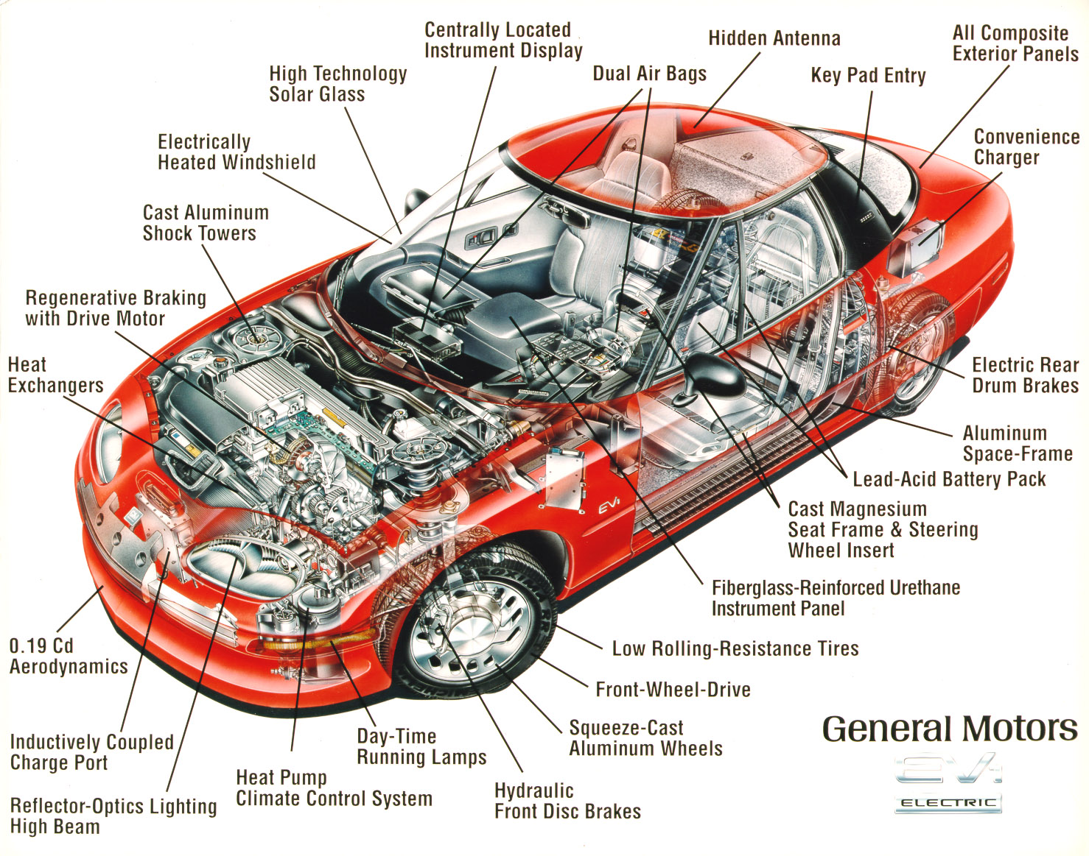



Task 1
Write a report illustrating the role and purpose of production engineer.
Guidelines (the more criteria covered correctly the higher the grade)
- Provide a description of the function Production, Design, Logistics, Collaborative Planning within a modern car manufacturing plant.
- Explain the role of the production engineer specifically in an automotive assembly area.
- Investigate how and why the production engineer can contribute towards design processes, products and services in automotive manufacture.
- Analyse how a production engineer supports the development of operational strategies linked to financial and production objectives in sub-contract manufacturing.

Task 2
Write a report describing production processes and associated facility arrangements, for manufacturing products/parts of different material types.
Guidelines (the more criteria covered correctly the higher the grade)
- Examine the properties and applications of ceramic products manufactured using the sintering, hot pressing, chemical vapour deposition (CVD) and reaction bonding processes: Include oxide ceramics, Carbides and Nitrides
- Describe the properties and automotive applications of composite products manufactured using manual and automated lay up, pultrusion and resin transfer moulding.
- Discuss the benefits associated with the polymer manufacturing process in relation to process capabilities regarding the production of a car dashboard.
- Evaluate using automotive examples how the choice of bonding and joining processes influence both the product design and effective production processes.

Task 3
Write a brief report on how a production system can incorporate a number of different production processes and the effectiveness of a production system in terms of its operation within the wider manufacturing system
Guidelines (the more criteria covered correctly the higher the grade)
- Review the type and sequence of production a door mirror might follow from initial design through to manufacture and sequence of production distribution.
- Describe the function of the following production facilities: Body, Chassis, Paint, Interior Assembly, and Mate in automotive manufacture
- Explain how automated materials handling equipment, conveyor systems, automatic guided vehicle servicing, product assembly and production lines will improve efficiency and effectiveness in automotive assembly.
- Analyse how JIT and Lean can be used to create a world class manufacturing organisation in the context of the supplier of the door mirror.

Task 4
Write a brief report exploring the effectiveness of a production system in terms of its operation within the wider manufacturing system

Guidelines (the more criteria covered correctly the higher the grade)
- With respect to automobile mass production, review the use of:
      - Through-put rates,
      - Yield rates,
      - Cost effectiveness,
      - Flexibility
      - Reliability
- Describe how collaboration creates end-to-end visibility and measures that can improve production performance criteria in the complex multi-tier automotive supply chain.
- Explain the long term effects of automotive production failures; internal and external, recall and rectification, when a subcontract manufacturer is supplying an OEM..
- Analyse how production performance can be measured across wider manufacturing areas such as cross-functional collaboration, openness to improvement, and engineering training. How are they related with regards to an automotive sub-contract manufacturer? What criteria of KPI’s can be used?

Learning Outcomes and Assessment Criteria
 |  |  | Pass |  |  |  | Merit |  |  |  |  | Distinction
 | LO1 | Illustrate the role and purpose of production |  |  |  |  |  |  |  |  | D1 Analyse how the  production engineer  supports the  development of  operational strategies  to achieve production  and financial  objectives
 | engineering and its relationship with the other elements
 | of a manufacturing system
 | P1 Describe the multiple  elements of a modern  manufacturing system  P2 Explain the role of the  production engineer within  a manufacturing system |  |  |  |  | M1 Investigate how the  production engineer can  influence the design process  and refine products,  services and systems
 | LO2 | Select the most appropriate production processes |  |  |  |  |  |  |  |  | D2 Evaluate how the  choice of bonding and  jointing processes  influence both the  product design and the  selection of the most  effective production  process
 | and associated facility arrangements for manufacturing
 | products of different material types
P3 Examine the properties  and applications of ceramic  products manufactured  using the sintering, hot  pressing, chemical vapour  deposition (CVD) and  reaction bonding processes  P4 Describe the properties  and applications of  composite products  manufactured using  manual and automated lay-  up, filament winding,  pultrusion and resin  transfer moulding  processes |  |  |  |  | M2 Discuss the benefits  associated with polymer  manufacturing process

 |  |  | Pass |  |  |  | Merit |  |  |  |  | Distinction
 | LO3 | Analyse how a production system can incorporate a |  |  |  |  |  |  |  |  | D3 Analyse the  relationship of just-in-  time (JIT) and lean  manufacturing to total  quality and world-class  manufacturing and  their effects on  production processes  for a given product or  assembly
 | number of different production processes for a given
 | product or assembly
 | P5 Review the type and  sequence of production  processes a product or  component would follow  from initial design through  to manufacture and  distribution  P6 Describe the function of  the various production  facilities within a modern  manufacturing plant |  |  |  |  | M3 Explain how materials,  components and sub-  assembly handling and  conveyance can impact on  the effectiveness and  efficiency of a modern  manufacturing plant
 | LO 4 | Explore the effectiveness of a production system in |  |  |  |  |  |  |  |  | D4 Analyse the criteria
 | terms of its operation within the wider manufacturing system |  |  |  |  |  |  |  |  |  | by which production
 |  |  |  |  |  |  |  |  |  |  | performance can be measured within the wider manufacturing system
 | P7 Review the type of data  that would be collected and  analysed to measure  production performance  P8 Describe the measures  that can improve  production performance  criteria |  |  |  |  | M4 Explain the immediate  and long term effects that  production errors and  rectification can have on a  manufacturing company

Assignment Feedback
Formative Feedback: Assessor to Student

Action Plan

Summative feedback

Feedback: Student to Assessor

Assessor signature |  | Date
Student signature |  | Date

